ImPACTS Outpatient Study Protocol

Background
Children with potentially life-threatening illnesses are sometimes taken to primary care offices, which often serve as the child’s medical home. Estimates of how often emergently ill children are taken to primary care offices vary widely, with numbers ranging from 1-2 a year to up to multiple patients seen weekly¹⁻³. While the frequency of these events remains somewhat in question, it is well established that pediatric primary care offices are ill prepared to care for emergencies, with multiple studies reporting wide variation in the available equipment, supplies, and level of preparedness for these patients despite the existence of established recommendations from the American Academy of Pediatrics (AAP)²⁻⁵.
Academic Medical Centers (AMCs) with specialized pediatric providers are committed to ensuring optimal health outcomes for all children in the US. To this end, it is critical that AMCs expand their influence beyond their own institutions to support community practices and provide a continuum of care, starting with patients’ entry points to medical care.
ImPACTS (Improving Pediatric Acute Care through Simulation) is a research and education network that aims to improve pediatric readiness and structure of care in the United States. They have established an effective educational model in community emergency departments with AMCs serving as “HUBS” and community hospitals as “SPOKES.” We seek to adapt this study design and methodology with community pediatric primary care practices serving as “SPOKES.” Each primary care practice will designate a champion to facilitate participation in the ImPACTS program. These champions will lead their emergency readiness improvement efforts over the duration of the study, with support from the HUB and ImPACTS coordinating center.
The intervention begins with an in-person emergency readiness assessment. This assessment involves a survey of the primary care practice (see below in methods) as well as a simulation-based assessment of the quality of care delivered to a set of simulated patients in either the patient rooms or waiting room of the practice. A performance report and gap analysis will be generated from the survey and simulation data by the ImPACTS team. This report will provide each spoke with a quantitative emergency readiness performance report as well as a comparison of their readiness to other pediatric primary care practices. This readiness performance report will be reviewed by the participating spoke and HUB through a “report out” within two weeks of the readiness assessment day. The “report out” meeting will involve presentation of data to the spoke champion and/or leadership team. After this presentation, the group will select two high priority “ImPACTS action items for improvement.” Action items will be specific, measurable, realistic, and time sensitive. Each of the action items will be linked to an “ImPACTS action plan” that includes resources and an explicit, realistic timeline for completion of the individual action item. Every two months the spoke and HUB teams will interact to review the progress of the action items. These interactions will address any of the issues impacting the successful completion of the action items and the emergency readiness scores. When an item is completed, the team will select a new high priority “ImPACTS action item” from the initial list. At the end of a six month period, a follow-up emergency readiness assessment day will be completed. The ImPACTS core team will create an updated report out including an updated gap analysis as well as a summary of the action items completed. The participating HUB and spoke sites will engage in discussions related to the future directions for the collaborative during this report out phase. The ImPACTS core will provide administrative support for participating HUB and spoke sites. The goal of this collaborative is for each of the participating spokes to complete the action items and improve the practice’s emergency readiness score by 10%.
Examples of action item/plan for improvement:
 | Action Item | Action Plan
Priority example 1 | No infant-sized BVM equipment available | Obtain appropriate size BVM equipment for infants (250ml)
Priority example 2 | No pre-determined plan/protocol for office response to an emergency. | Create plan for office emergency response including defined rolls and tasks.

Specific Aims:
Aim 1: To evaluate the impact of our intervention on the emergency preparedness of participating pediatric primary care practices as measured by percent adherence to an emergency readiness checklist based on existing AAP guidelines.
Hypothesis 1: An improvement in readiness, measured by scoring on validated checklists regarding equipment/supply availability and provider performance, will be noted between the first and follow-up assessment.
Aim 2: To evaluate the impact of our intervention on the structure and process of care provided to simulated emergently ill patients in pediatric outpatient offices.
Hypothesis 2: Practice performance in simulated pediatric emergencies will improve after initial evaluation and participation in this project
Optional/Exploratory Aim:
To identify common themes/trends regarding barriers to providing high quality care to emergently ill pediatric patients in pediatric primary care offices. AMCs participating in this aim will record and review structured debriefings after simulated emergencies, as well as self-reported reports of practice performance in actual emergencies of participating practices for common issues or themes.
Inclusion/Exclusion Criteria:
Inclusion Criteria:
- “HUB” Academic Medical Centers will be recruited to participate and include a hospital with pediatric emergency and/or intensive care specialties. Sites will be required to complete a train-the-trainer session if they have not already completed one during a prior ImPACTS study and submit a letter of commitment to enroll at least three primary care offices within one year.
- “Spoke” Pediatric primary care offices in urban/suburban settings not physically attached to hospitals or emergency departments will be chosen for this study. Offices should have an EMS response time of <15 min to be considered in an urban/suburban setting. Additional commitment letters from each office will be submitted to the “HUB” after scheduling the assessment and follow-ups. Offices that host medical trainees are available for enrollment, but trainees should not participate in the simulations in order to limit confounding levels of exposure to acutely ill patients.
Enrollment:
Spoke and HUB sites will voluntarily join ImPACTS through a set of collaborative agreement letters (between hub and “ImPACTS core” as well as spokes with hubs). The ImPACTS core will provide a standardized protocol (turnkey approach) for spokes to collaborate with hubs. Participating spokes will have access to quality improvement and educational content that can be shared by the HUB with each participating community site. The goal of this to have all the needed resources, guidelines and policies readily available in a centralized folder that can be accessed by HUBs and spokes at any time. If certain resources are needed but not available, the ImPACTS core will help obtaining them and coordinate with the HUB site accordingly. This project will not involve randomization.
HUBs recruitment, collaboration and standardization:
Participating HUBs will join ImPACTS through a formal collaboration agreement. The HUB will complete training with the “ImPACTS core” using “Train-the-Trainer” approach to ensure standardization in the structure and process of this intervention. If the HUB has been previously trained there is no need to be retrained. HUB team should include health care providers with a solid background in health care education using simulation. The team may include but is not limited to: pediatric emergency physicians, pediatric critical care physicians, nurses, respiratory therapists and nurse practioners. Each HUB will be provided a turnkey approach to collaborating with spokes including QI/PI/clinical practice/education. Each HUB will identify at least three spokes that will participate on a voluntary basis and commit to participating in all required elements of the program. The spoke, in order to liaise with the HUB team, will identify a nurse and/or physician champion(s). This individual will coordinate the in-person emergency readiness survey assessment, the simulations, and all follow-up interactions with the HUB upon the initial agreement.
Spoke recruitment:
The HUB sites collaboration with spokes will involve discussions about the program vision and mission and set the expectations from each spoke site in addition to having the commitment letter signed upon agreement. Initial agreement will be performed between the HUB Liaison and the spoke leadership. Subsequently, after an individual has been identified at the spoke as a “champion,” they will serve as the site contact. The ImPACTS model involves the academic medical center team working with that individual to arrange for site visits and subsequent communications. ImPACTS core will provide support to all HUB sites throughout the recruitment process and consultation with the core experts regarding the initial recruitment.
Study Phases:
1 – Baseline Emergency Readiness and Quality Assessment
This initial site visit involves the HUB team going to each participating spoke site to conduct:
- Pediatric Outpatient Readiness Survey (PORS): The liaison from the HUB will visit each spoke site and use the PORS to document an emergency readiness score (Appendix 1). All items on the checklists will be examined in person with the spoke “champion.” If the “champion” is unsure or unable to identify an item, it will count as non-existent. This checklist will also include basic practice information and demographics regarding providers and patients.
- In situ simulations: The HUB team will conduct two simulations: respiratory distress (represented by asthma) and seizure (Attachment 1). These simulations will involve inter-professional team members using the local usual practices, policies, procedures, equipment, and resources. Spokes will be expected to provide their own supplies and equipment (medications, respiratory support equipment, etc.), but the simulation team will have all necessary equipment and supplies available to replace the spoke’s supplies prior to use in order to prevent them from incurring costs due to this study. Given the nature of these scenarios, these supplies will be minimal and reusable for subsequent simulation sessions. The HUB team will supply and set up simulation equipment and video equipment in either an examination room or office waiting room based on the simulation scenario. The scenarios will be followed by a constructive, structured, and standardized debriefing session. The collaborative team will answer any questions about emergency readiness related to the scenarios and provide education materials to participants. Prior to the simulations, demographic data and consent for video recording from participating team members will be collected. A list of this demographic data is included (Attachment). Teams of providers will be comprised of the normal distribution of individuals participating in patient care during most operating days of the facility.
- Data Collection: The HUB team will score each spoke using checklists for each case completed during direct observation and a subset of cases will demonstrate inter-rater reliability/generalizability of the checklist through application by a blinded video reviewer. A standard Clinical Teamwork Scale (CTS) will be used to evaluate teamwork during all simulations (Appendix 2). The simulation-based performance checklists will be collected on paper forms by the HUB teams and entered into a centralized data collection form in addition to the emergency readiness scores and CTS within 48 hours of completing the initial visit using the following link: https://survey.az1.qualtrics.com/jfe/form/SV_5jsXuCc5Lgj3JQh

2- Gap analysis, action items, and action plans
This phase will consist of:
- Report outs with action items: After the simulations at the spoke site, each HUB will complete electronic data forms that will go to the ImPACTS core for data analysis within 48 hours of the sim session. The ImPACTS core team will transform that content into a standardized “ImPACTS report out” to be sent out to the HUB. Additionally, ImPACTS will support the HUB team as they interact with the spoke site lead to review the report out score and select two action items to complete for the first two months following the call. One initial action item will be selected from the equipment portion of the readiness checklist, and one will be selected from the protocols/policies/guidelines portion of the readiness checklist. As these items are completed additional items will be added from the data set.
Each HUB will schedule a conference call or in person visit with the spoke site within two weeks of the initial site visit. During this meeting with the spoke site champion (and leadership), the HUB team will review the compiled data including clinical performance, safety threats, readiness scores, and discuss opportunities for improvement that came up either during the simulation, debriefing, or PORS survey. The site will receive a copy of the report, which will include their emergency readiness score, simulation performance data, and action items.
Action items will be prioritized to be completed within the 6 months time frame following the call. These action items will be SMART (specific, measurable, actionable, realistic and timely). After each action item is complete a new item will be added from the initial list. The action items will include a detailed plan for improvement. The item will only be considered complete after the measurable evidence as described in the protocol has been provided to the HUB.
Access the ImPACTS library; an online resource of peer-reviewed articles related to pediatric emergencies and readiness will be available for spoke sites.
- Outgoing interaction (Hub to spoke): The HUB site will be supported by ImPACTS core as they work to follow-up with spoke sites. Additional outgoing communications (from HUB to spoke) will be scheduled at 2 months and 4 months using a conference call or on-site visit. The discussions will include updates on implementation of action items, any difficulties encountered, or educational needs identified. The HUB will be responsible to collect evidence of completion of action items per the protocol (as described for each item) and submit this to the ImPACTS core. After each item is completed the HUB will provide the site with an additional item from the list. Incoming interactions (from spoke to HUB) will be encouraged and will happen based on the need of each spoke site for further assistance or input from the HUB. These interactions will be tracked and logged using the same log to document all interactions.
- Repeated follow-up in-person visit: A follow up visit of the spoke sites will be conducted by the same methods as described above approximately six months after the initial simulation to provide re-assessments of the PORS and simulation-based performance at the end of the study period.
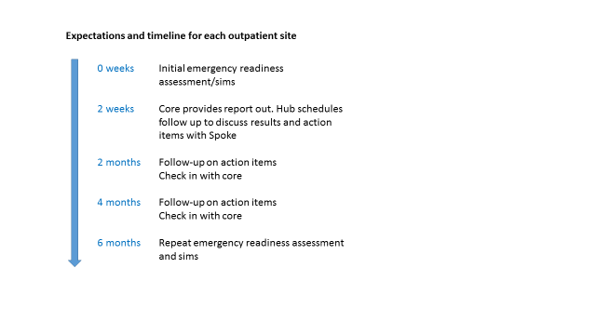
Project Facilities:
ImPACTS leadership will establish a steering committee that will oversee the process of this project throughout the whole study period. This steering committee will have representatives from ImPACTS Core HUBs in addition to the project manager, community representative and the committee chair.
The key to ImPACTS’ success is buy-in from regional Academic Medical Center HUBs that will serve as primary contacts to local sites in their regions/states. Academic Medical Centers interested in becoming “HUBs” will participate in a conference call with the ImPACTS leadership team on a regular basis. This ongoing communication between the ImPACTS Core and all HUBs will guarantee a standard approach to the project and maintain a line of mutual feedback and ongoing support for all regional centers. These HUBs will go to at least three spoke sites in a year to assess their readiness for pediatric emergencies and conduct in-situ simulations.
ImPACTS Structure and Relationships Goes Here
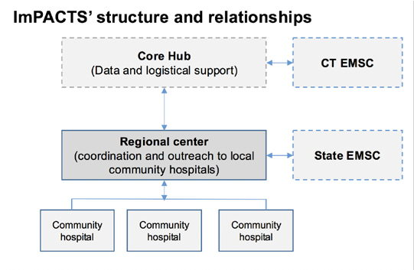

ImPACTS Organizational Structure Graphic Goes Here
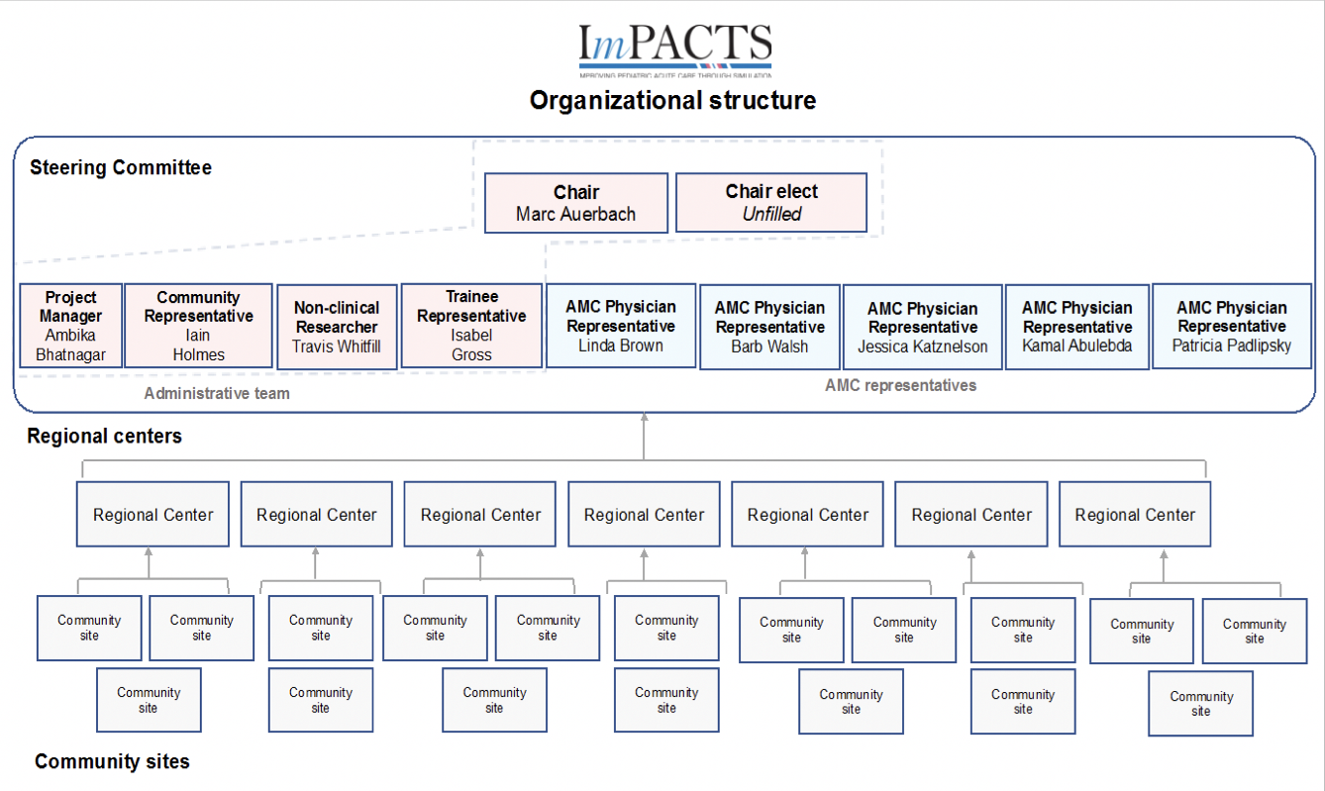

HUB ImPACTS Team:
The team will be recruited from participating academic medical centers in each region/state and aims to include providers from different medical backgrounds (EM, ICU, and critical care transport) and professions (RN, MD, DO, APRN, PA, RT). A minimum of one physician and one non-physician provider are required to participate as a HUB. All faculty will have training in the use of high-fidelity simulation mannequins, simulation scenario design, and structured debriefing methods. Additionally, all HUBs will have completed “train-the-trainer” either during a prior ImPACTS project or prior to beginning this study to understand the ImPACTS model.
Participant Team:
Each team will consist of the usual staff present at participating pediatric primary care office including but not limited to: pediatricians, nurses, nursing assistants, respiratory therapists, and front office staff.
Simulation Session:
A champion will serve as a liaison for the spoke site to ensure all the logistics of the simulation day are in order. Staff expected to participate in the simulation should mimic the site’s normal activity and staffing pattern. This will vary depending on the make-up of individual clinic staffing, but should include at minimum a pediatrician and/or nurse practitioner and nursing. Additionally, location of the in-situ simulation needs to be in an examination room or clinic waiting room, depending on the specific scenario. This ensures more realism and mimics the location where a pediatric emergency would present. Duration of the day will be approximately 2 hours including pre-simulation readiness assessment, set-up, simulation (2 scenarios), and debrief. Permission to use all the location’s available equipment will be required, with the understanding that the simulation team will replace any necessary equipment to the scenario with their own equipment to prevent participating clinics from incurring costs due to participation in this study.
Simulators:
We will use a 20 kg child (SimJunior/Megacode Kid) simulator for this project based on each center’s available equipment.
Video:
All simulation sessions will be videotaped using B-Line Medical “SimCapture” or a similar video program. All videos will be stored in the central memory of B-Line or uploaded to this system if a HUB uses another method to record video. A random sample of 10% of the cases will be reviewed by a blinded individual to compare the scores to each HUB’s score for the case.
Audio:
Audio recordings of the structured debriefing sessions will be recorded and stored in the central memory of B-Line, or uploaded to this system if a HUB uses another method to record audio. These recordings will be transcribed and reviewed for common themes/trends regarding barriers to providing ideal care in emergencies.
Continuing Education Credits:
Centers may incentivize participation of primary care providers and nursing/respiratory therapists by offering continuing education credits for the participants. Physicians will be offered continuing medical education (CME) credits. Nurses and respiratory therapists will be offered continuing education units (CEU) as well from each region/state HUB. Each HUB will be responsible for managing CME/CEU credits for their own site.

1. Yuknis ML, Weinstein E, Maxey H, et al. Frequency of Pediatric Emergencies in Ambulatory Practices. Pediatrics. 2018;142(2).
2. Fuchs S. Pediatric office emergencies. Pediatric clinics of North America. 2013;60(5):1153-1161.
3. Frush K. Preparation for emergencies in the offices of pediatricians and pediatric primary care providers. Pediatrics. 2007;120(1):200-212.
4. Fuchs S, Jaffe DM, Christoffel KK. Pediatric emergencies in office practices: prevalence and office preparedness. Pediatrics. 1989;83(6):931-939.
5. Toback SL, Fiedor M, Kilpela B, Reis EC. Impact of a pediatric primary care office-based mock code program on physician and staff confidence to perform life-saving skills. Pediatr Emerg Care. 2006;22(6):415-422.

